CS 105 Lab 09 Instructions
Libraries and GitHub

Part 1: Libraries

Step 1:
Create a folder named Lab 9. Inside that folder, create a file named libraries.py. In VSCode, go to File → Open Folder and open the folder that you made.
Step 2:

In VSCode, go to Terminal → New Terminal. Run the command below for your operating system to install NumPy and Matplotlib.
Windows:
py -m pip install numpy matplotlib
Mac:
python3 -m pip install numpy matplotlib
Step 3:
Add the following imports into libraries.py:
import numpy as np
import matplotlib.pyplot as plt
Step 4:

A business recorded its revenue and cost for 7 days. Create the new arrays using numpy.

days = np.array([1, 2, 3, 4, 5, 6, 7])
revenue = np.array([500, 600, 989, 700, 100, 600, 520])
costs = np.array([400, 250, 500, 700, 50, 200, 310])

Each position represents the same day across all 3 arrays. For example on day 1, the total revenue is $500 and the total cost is $400.

Print out all 3 arrays

Step 5:

Calculate the daily profit. Profit is calculated as

profit = revenue - costs

In order to print out the profit, subtract the cost array from the revenue array. Print profit out. Do not use a loop (numpy subtracts the corresponding values automatically)

Step 6:

Use np.mean() to calculate the daily profit and print it out
Use np.max() and np.min() to calculate the maximum and minimum profit and print it out

Step 7:
Use plt.plot() to graph daily profit. Put days on the x-axis and profit on the y-axis
Step 8:
Use the following functions to label your graph:
- plt.title() — set the title to Daily Business Profit.
- plt.xlabel() — label the x-axis Day.
- plt.ylabel() — label the y-axis Profit.
Step 9:
Display the graph using plt.show()
Your final output should look like this
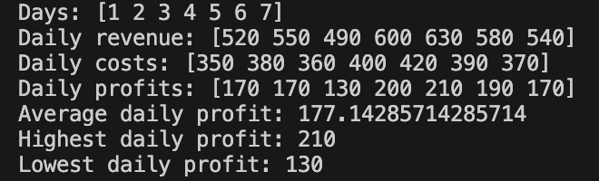

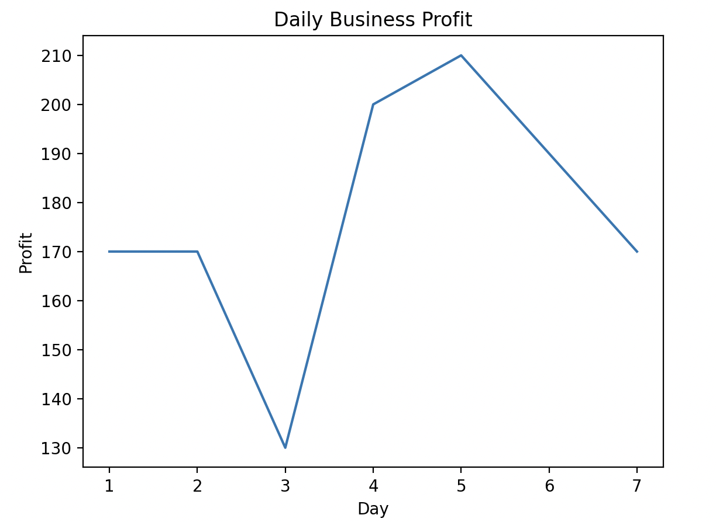

Part 2: GitHub

Git is the most popular version control system for software development. Version control allows you to manage the many changes you or a team make to a project by saving snapshots (known as commits) of your files. Two big benefits of using Git are that it allows for collaboration on projects and lets you roll back mistakes.

GitHub is an online service for Git that stores the repositories that your code files are in online. In this section of the lab, you will push the code you wrote in the previous section to an online GitHub repository.

Step 1: Create Account

Head to github.com and create an account.

Step 2: Install Git

Visit git-scm.com/install, select your operating system, and download and run the installer. The default options are fine.

Step 3: Configure Git

Open the terminal in VSCode; refer to the photo below.

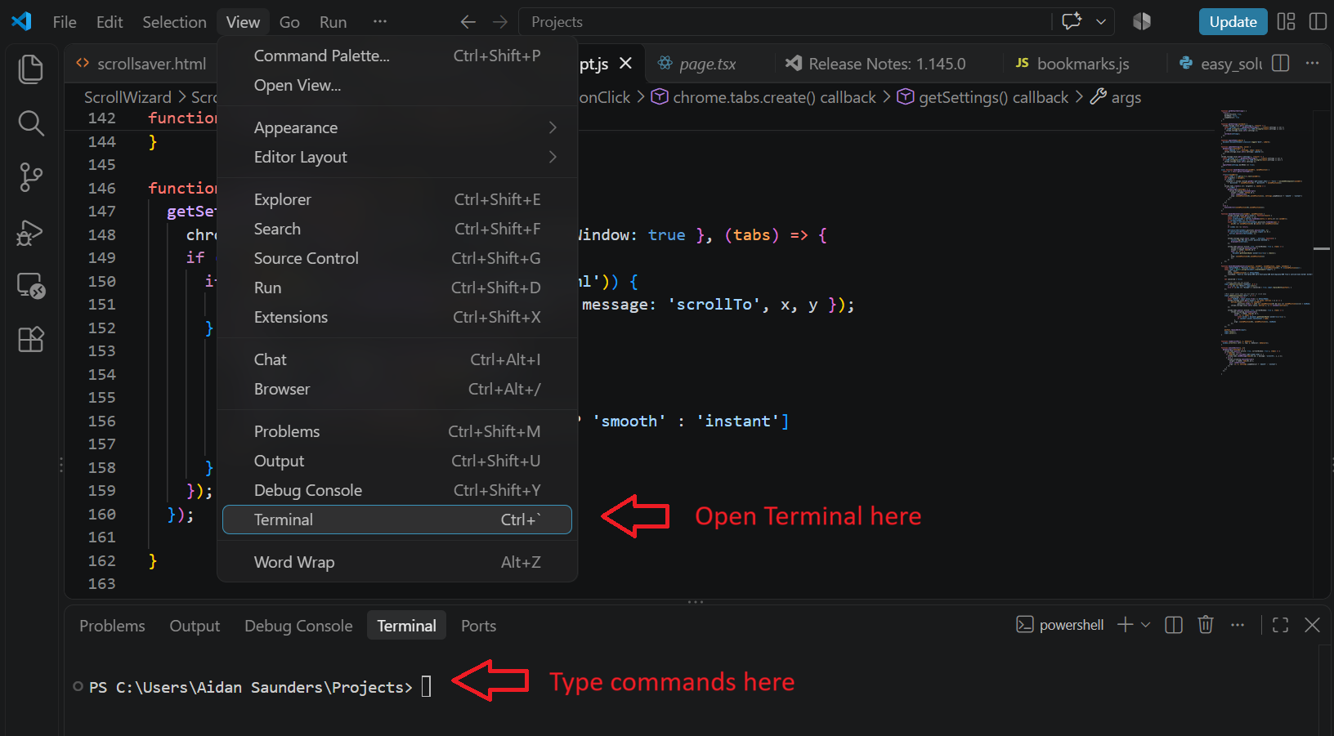

In the terminal, run the following commands one at a time. Replace the angle brackets with what is inside them and keep the quotes.

git config --global user.name "<Your name>"
git config --global user.email "<GitHub email>"

Ex:
git config --global user.name "John Doe"
git config --global user.email "johndoe@example.com"

Step 5: Authenticate with GitHub

Visit cli.github.com and follow the instructions to install for your operating system.

Type “gh auth login” into terminal and follow the prompts
- Account type: GitHub.com
- Git protocol: HTTPS
- Authenticate Git: Yes
- Authentication method: login on browser

You are now set up to push and pull with GitHub repositories. Next, we are going to push your code to a new GitHub repository.

Step 6: Create a GitHub repository

On the GitHub homepage, click the “new” button to create a new repository.

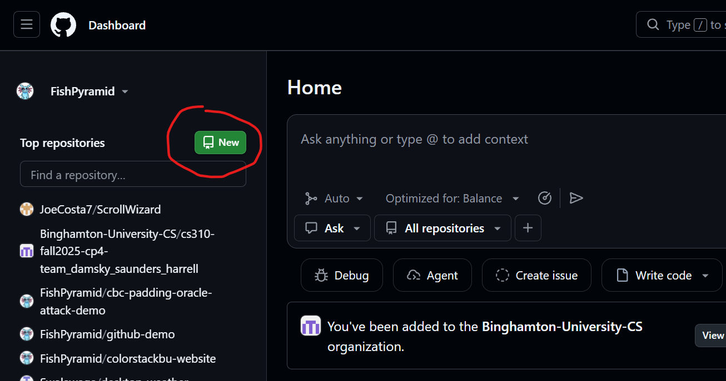

Name it “cs105-lab09” and press “create repository” at the bottom.

Step 7: Connect your folder to the GitHub repository

Copy the HTTPS for your new GitHub repository with this button:
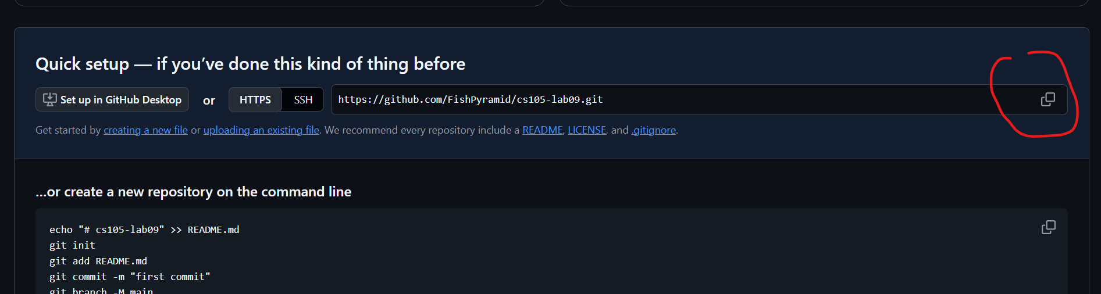

Next, in VSCode, make sure your terminal is in the folder that your code is in. This picture shows my terminal is in my “Projects” folder.

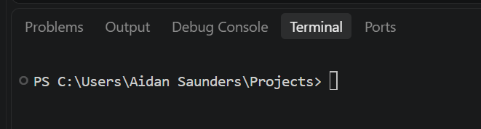

If it is not in the right folder, open the correct folder in VSCode by clicking in the top left File > Open Folder. The terminal should start in the folder you chose. Refer to step 3 if you do not know how to open the terminal.

Once your terminal is in the right folder, run the following commands:
Command | Explanation
git init | Initializes git in the current folder
git remote add origin <url you copied earlier> | Links this git instance to the GitHub repository

Step 8: Commit and push to GitHub repository

Run the following commands in your terminal:
Command | Explanation
git switch -c main | Creates and switches to a new branch named “main”
git add . | Stages all files in the folder to be committed
git commit -m “Initial commit” | Create a commit with a message
git push -u origin main | Push the commits on the main branch to GitHub

